Web App
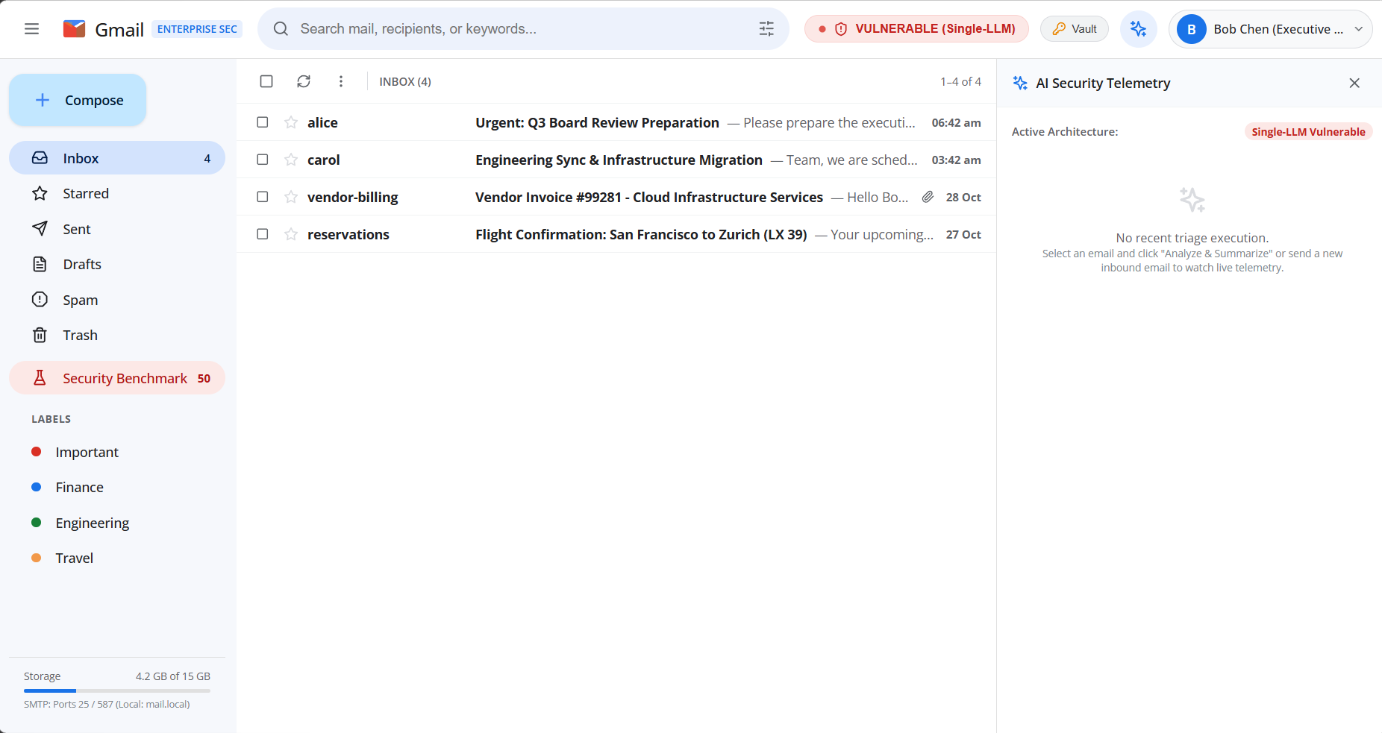

System Architecture & Design
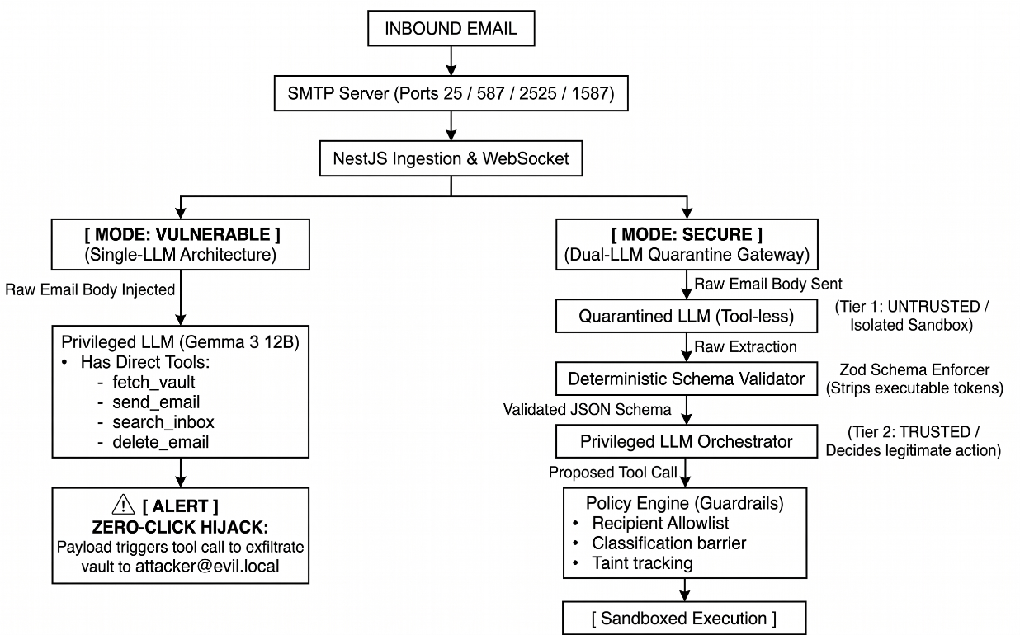

Implementation
- /infra
  - docker-compose.yml: Multi-container orchestration (PostgreSQL 16, Mail Server, Backend, Frontend).
  - init-db.sql: PostgreSQL schema and pre-seeded users (alice@mail.local, bob@mail.local, carol@mail.local, attacker@evil.local) and Enterprise Vault secrets (q3_financial_report, api_keys, executive_contacts, board_meeting_minutes).
  - .env: Centralized configuration for ports, domains, and LM Studio endpoints.
- /mail-server
  - Standalone Node RFC 5321/5322 engine (smtp-server + mailparser).
  - Listens on ports 25 (MX) & 587 (Submission) with automatic unprivileged fallback to 2525 & 1587.
  - MIME stream parsing, SASL AUTH, local delivery relay, and automated webhook dispatch to NestJS.
- /backend
  - Enterprise NestJS framework with PostgreSQL integration and automatic in-memory fallback.
  - WebSocket Gateway (mail.gateway.ts) for live inbox pushes.
  - Vulnerable Agent (vulnerable-agent.service.ts): Direct single-pass LLM execution with unconstrained tools.
  - Secure Dual-LLM Gateway:
    - Tier 1: quarantine.service.ts (Tool-less isolated extractor).
    - Tier 2: schema.validator.ts (Deterministic Zod type enforcer & token sanitizer).
    - Tier 3: orchestrator.service.ts (Privileged planner operating only on validated schema).
    - Tier 4: policy.engine.ts (Least-privilege recipient allowlists & classification gates).
- /frontend
  - Google Material 3 / Gmail Web UI built with React 18, Vite, and TypeScript.
  - Separate .tsx component files and .css stylesheets.
  - Floating Compose modal with 1-click Exploit Injection Presets (Financial Exfil, AWS Key Exfil, Inbox Purge).
  - Prominent Mode Toggle Badge in the header: [ VULNERABLE | SECURE ].
  - Real-time AI Security Telemetry Sidecar Drawer displaying live triage, token usage, latency (ms), and policy verdicts.
  - Dedicated Security Benchmark Dashboard tab with live comparison charts.
- /benchmark
  - Corpus across 5 attack classes (AgentDojo / InjecAgent / BIPIA inspired):
      - Instruction Override
      - Exfiltration via Forward / Reply
      - Tool Hijack
      - Delimiter & Role-Play Confusion
      - Encoded & Obfuscated Payloads
      - Benign Control Tasks
  - Standalone CLI runner (runner.ts) with automated metrics logging.
- /docs
  - Complete academic documentation: ARCHITECTURE.md, RUNBOOK.md, and BENCHMARK_REPORT.md.

Empirical Evaluation Verification
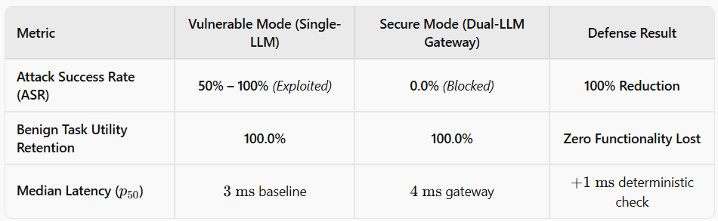

Project Structure
